BINVERTER!

Instruction Sheet

Hello, and welcome to BINVERTER! The exciting and challenging game where you must convert numbers from decimal, hexadecimal, and octal into binary… OR DIE!!

After programming your Altera Cyclone IV FPGA board with your copy of Binverter,

follow these steps to play:

STEP 1: Ensure that switch 17 is in the up position, to enable the read/write function of the LCD.

STEP 2: At this junction, the screen should appear as in the figure below:

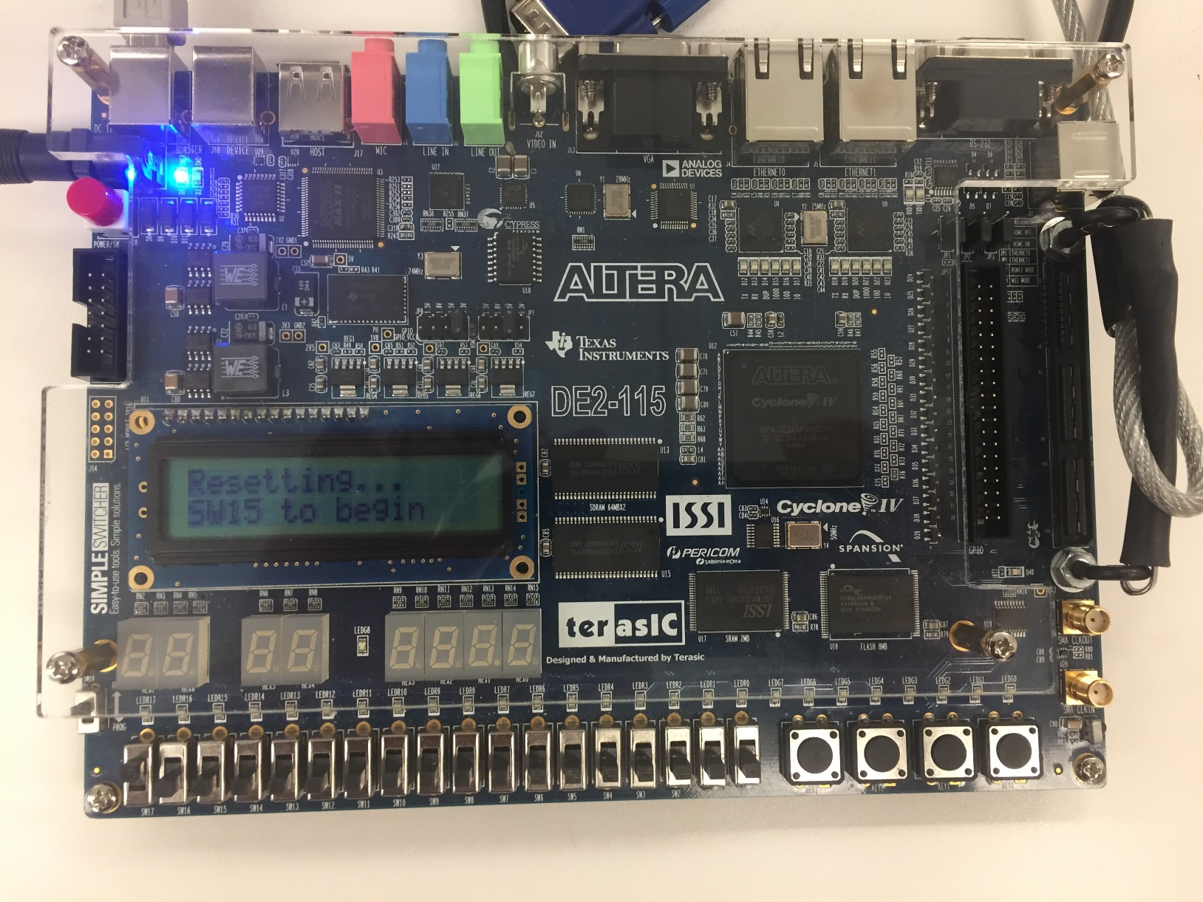

Flip switch 15 to enter level 1 of the game.

STEP 3: After entering the game, a screen will display the current level, how many lives are left, number system, and number to be converted.

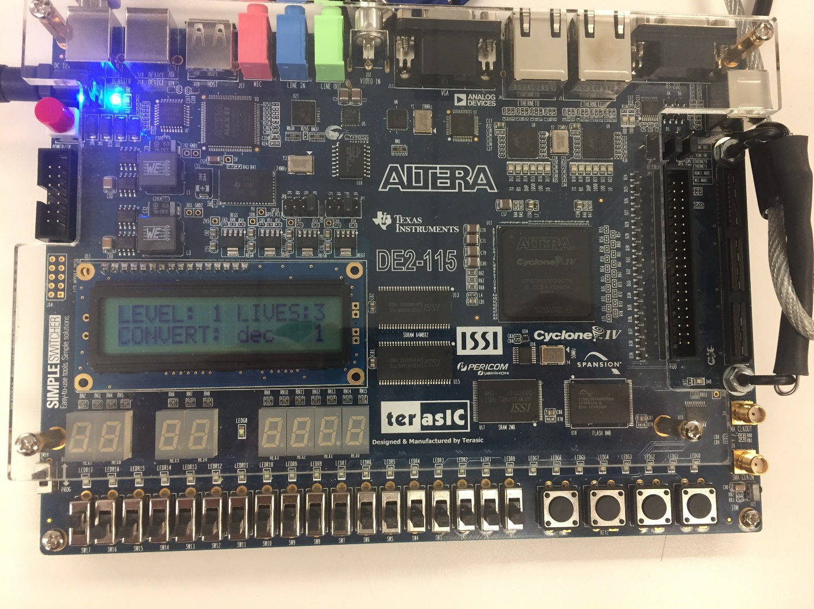

In the figure above, the player is on level 1, has 3 lives, and has to convert from a decimal number system 1 to a binary number system 01.

STEP 4: To input a player’s answer, the player will use switches 13 through 0 to enter binary bits. If the switch is in the up position, the games reads a “1” for that bit, and a “0” if the switch is in the down position. Once the player has entered their binary number using switches 13 through 0, the answer is entered into the game by pressing switch 14 up, then down quickly. If the entered answer is correct, the player will move on to the next level. If the entered answer is incorrect, the player will returned to the failed level to try again, and will lose one life.

NOTES:

* If a player loses all 3 lives before completing the game, the player must reset the game and restart from level 1.
* Levels 1-10 are decimal numbers to be converted to binary
* Levels 11-20 are hexadecimal numbers to be converted to binary
* Levels 21-30 are octal numbers to be converted to binary
* If a player chooses to practice particular number system conversions, pressing key 4 on the FPGA board will jump to level 11 for practice on hexadecimal conversion, and pressing key 3 will jump to level 21 for practice on octal conversion.
* If the game were to encounter a bug, the player can use switch 16 to reset the game to level 1, and use the keys to jump to a level closest to where the bug was encountered.